Boys Dance! By John Robert Allman |  |  | Pennsylvania Young  Reader’s Choice Award  Activity Booklet  K-3  Name  [Company Name]  - [Subtitle]

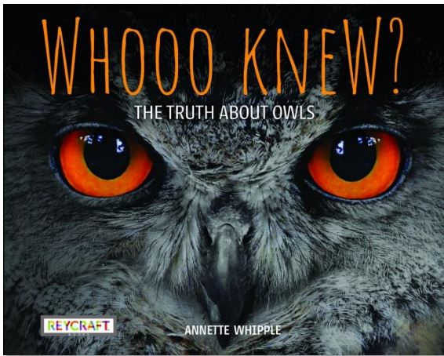  Whooo Knew? The Truth About Owls  by Annette Whipple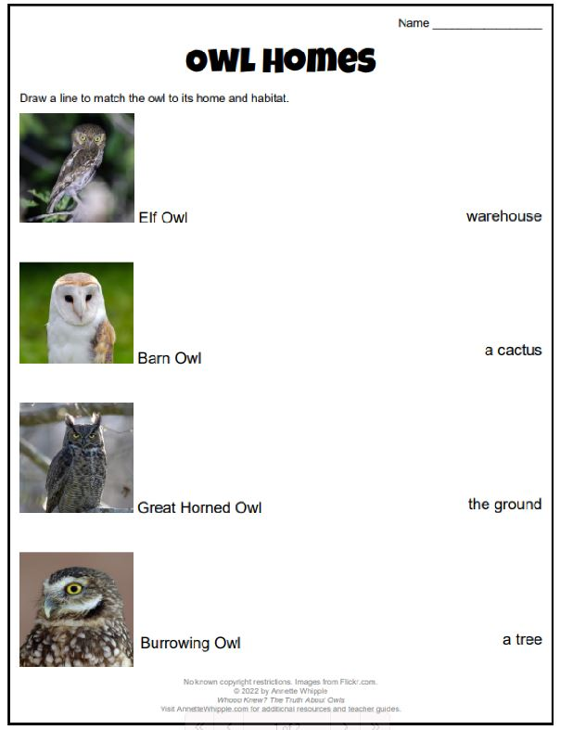 |  |  | 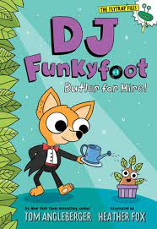  DJ Funkyfoot: Butler for Hire  Draw and color your own ShrubBaby.  by Tom Angleberger  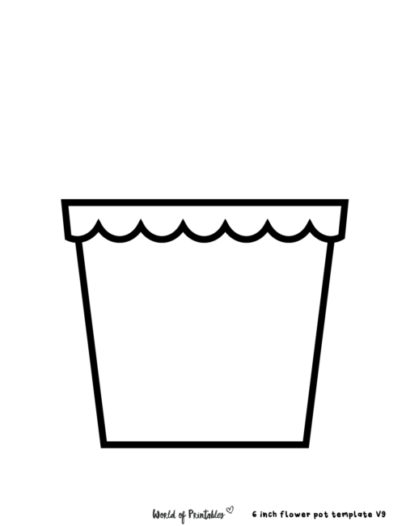
 |  |  | 5

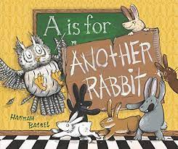  A is for Another Rabbit  by Hannah Batsel  A is for Another ___________________________.  Draw it below.  . |  |  | 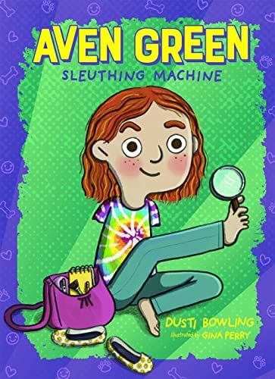  Aven Green Sleuthing Machine  by Dusti Bowling  What will Aven Green solve next? Write or draw about it below.  The Case of the Missing_____________________________.
4 |  |  | 1

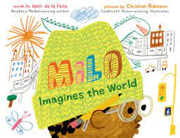  Milo Imagines the World by Matt de la Pena  Draw yourself in a hat and recreate the cover with your own imagination. 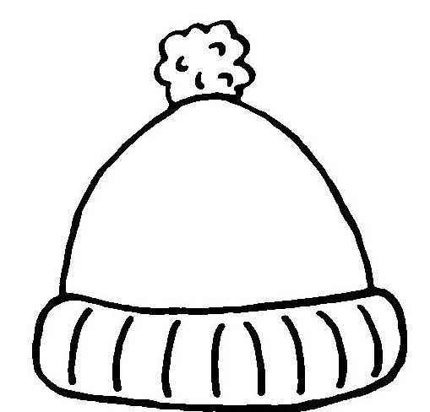 |  |  | 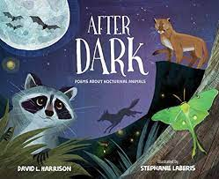 by David Harrison  After Dark: Poems about Nocturnal Animals  Finish this poem about a skunk at night.  The little skunk is black and ___________________________.  Try not to startle him at ________________________________.  For if you do, I’m sad to tell,  He will leave you with an awful_________________________.  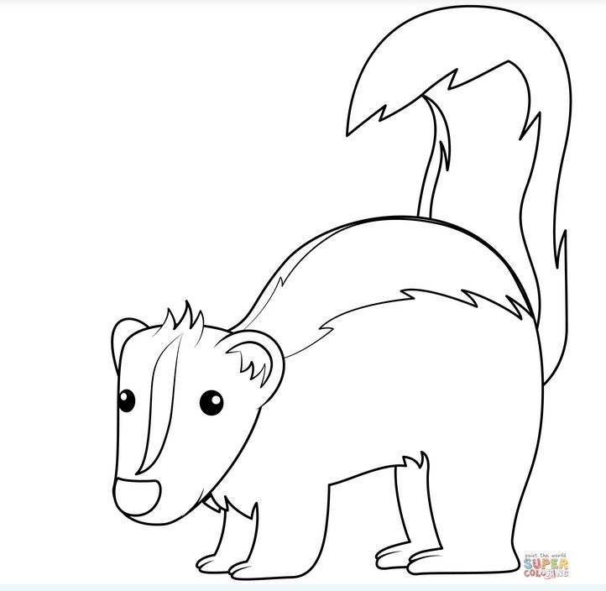
2 |  |  | 3

